SPORTS AND KEEPING FIT - USEFUL VOCABULARY
Do you think these verbs might be helpful when talking about sports and keeping fit?
- take up a sport
- give up a sport
- to win a (swimming) competition
- to take part in a competition (a contest, a championship, a tournament)
- to participate in a skiing competition
- to train hard/ for one hour/ to run a marathon
- go jogging a couple of times a week
- to play a sport for fun /professionally
- to keep fit
- to get injured
- to score a goal
- to work out
- to warm up before working out

More words and expressions you might need to know are:
- Team sport/individual sport
- sports centre
- physical activity
- extreme sports
- a sporty person/ a sportsman,a sportswoman
- I am a big football fan
- I am really keen on sports/ playing tennis
- it is important to keep fit
- the thing is to get started
- to be concerned about your health
- Playing tennis makes me feel better
- indoor sports/outdoor sports
- to play a game of tennis/football/chess
- to be a sports fan/ a football fan
- to have the latest sports facilities

Tick what is true for you

1. When I do sport I feel .....
full of energy
energetic
active
cheerful
fit
healthy

2. It helps me
socialise
stay in shape
keep fit
relax
www.cristinacabal.com

unwind
sleep better
lose weight
burn calories faster

3. It Improves
my mood
my fitness
my mental fitness
my health
my muscle /’mʌsəl/tone

4. Doing yoga
needs too much physical effort
may cause injuries
can be done anywhere
can be practised in all age groups
requires expensive equipment

REMEMBER

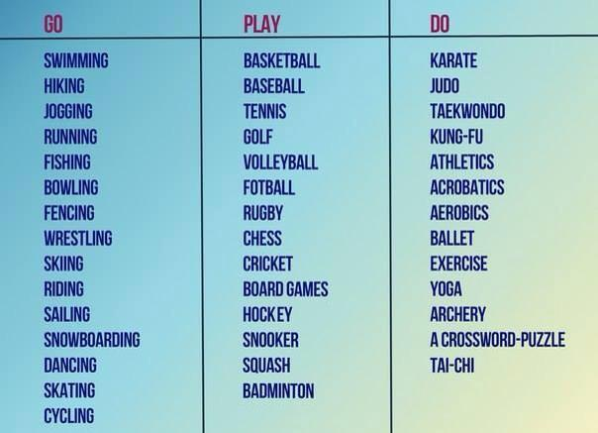

www.cristinacabal.com

